Answer sets for assignment 5.

05a.dta. These are data from marathon runners (again). Which of the following is associated with how fast runners complete the marathon: age, sex, training miles, weight?
My guess here is that we are going to want to do a regression analysis. This would allow us to quantify the association between the various predictor variables and race time. For example, it would be interesting to know not only that number of weekly training miles is correlated with race time, but by how much you can reduce your race time if you increased your training by a certain amount. Our dependent variable is “rt” (race time in minutes) so we could just type: “regress rt age sex tr wt”. The p values for all the predictor variables apart from weight are very low. A model answer might be:

There were 262 runners in the data set; full data were available for 217. Summary data for these 217 patients are given in table 1. Predictors of race time are shown in table 2. Age, sex and number of training miles were all statistically significant predictors of race time; weight is unlikely to have an important effect.

Table 1

Age (years) | 42 SD(10.7)
Female | 61 (28%)
Training miles per week | 36 SD(13.2)
Weight in kg | 76 SD(15.9)
Race time in minutes | 246 SD(45.3)

Table 2
Predictor | Increase in race time per 1 unit increase in predictor | 95% C.I. | p
Age (years) | 0.81 | 0.31, 1.31 | 0.002
Female | 23 | 11, 35 | <0.0005
Training miles per week | -1.49 | -1.89, -1.08 | <0.0005
Weight in kg | 0.05 | -0.29, 0.39 | 0.8

A real-life decision you could take away from this is that every additional mile you run in training would be predicted to cut about 1.5 minutes from your marathon time: add a couple of extra five mile runs per week and you’ll shave a quarter of an hour off your time.

A couple of thoughts. First, you will note that I didn’t remove weight from the model (that is, use a step wise approach) and then report the co-efficients and p values for the new model (by typing “regress rt age sex tr”).

Second, race time is not normally distributed and the textbooks would have us believe that this invalidates a regression analysis. Let’s try:

g lt=log(rt)
regress lt age sex tr wt

This creates a new variable called ‘lt” that is the log of race time. The Shapiro-Wilk test confirms that this is normally distributed. Now let’s look at the results of the regression analysis: the p values are almost exactly the same. This suggests that the non-normality of race time is not important in this setting.

For advanced students only

It might be interesting to compare the coefficients from the untransformed and log transformed models. For example, women are predicted to run about 23.2 minutes slower on the untransformed model; the coefficient in the log model is 0.098. Backtransform by typing “disp exp(0.098)” and you get 1.10. Remember that backtransforming gives you a proportion. So to work out the difference between men and women in race time, work out the average men’s time (“sum rt if sex==0” which gives 238.6 minutes) and multiply by 1.10 (which gives 262.4) to get the women’s time. Subtract one from the other to get 23.8 minutes difference in race time between the sexes. This is very close to the value from the untransformed model.

05b.dta. These are data on patients with a disease that predisposes them to cancer. The disease causes precancerous lesions that can be surgically removed. A group of recently removed lesions are analyzed for a specific mutation. Does how long a patient has had the disease affect the chance that a new lesion will have a mutation?

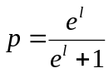What you are trying to predict here is binary (mutation / no mutation). You are predicting with a continuous variable (length of disease). So a logistic regression would work nicely. Try “logit mutation c”. Using the “logistic” function, you get an odds ratio of 1.14, meaning that the odds of having a mutation increases by 1.14 each year. “Logit” gives you a coefficient of 0.13 and a constant of 0.94. This can be used to make a specific prediction using the equation below (l stands for the log odds).

Take someone who has had the disease for 10 years. Their logit is 10 x the coefficient of 0.13 minus the constant (0.94) to give 0.36. Plug 0.36 into the equation (“disp exp(0.36)/(exp(0.36)+1)”) and you get 59%. Someone who has had the disease for 3 years has a
logit of –0.54 giving a risk (“disp exp(–0.54)/(exp(–0.54)+1)”) of 37%.

If you wanted to get flashy, you could work out the risk for each year between 2 and 18 and get a graph. But Stata can do this automatically for you: “predict risk” gives a new variable called “risk” which gives the risk of mutation for each observation in the data set on the basis of the duration of disease. (see below).

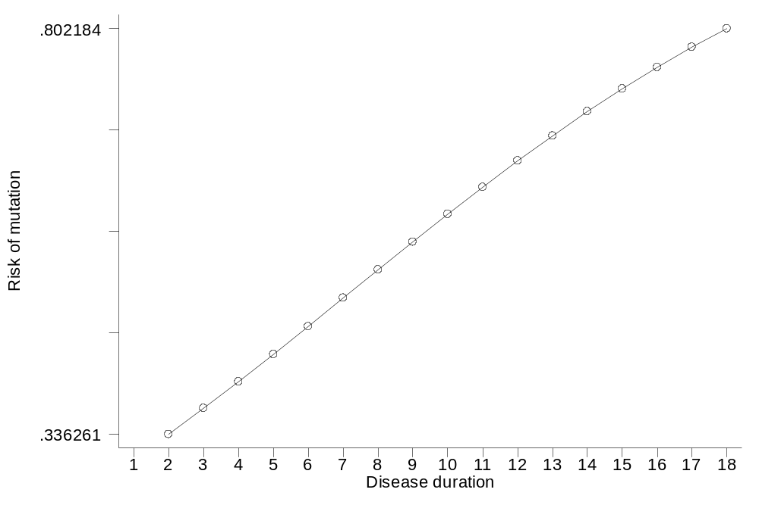
You can also use the “predict” command for linear regression and multivariable models. One other interesting thing you can do is to make “out of sample” predictions. Try this: open 05b.dta again. Then type:

logistic mutation c
replace c=_n/3
* _n is the observation number. Replacing c with _n/3 creates
* a list of simulated disease durations between 0.33 and 38.333.
predict risk
twoway (line risk c, sort)

05c.dta. These are data from Canadian provinces giving population, unemployment rates and male and female life expectancy. Which of these variables are associated?

A key first question: what are we likely to be interested in? For example, total population and unemployment rate will have no illuminating relationship whatsoever and we wouldn’t want to analyze the association between these two. The link between unemployment and life expectancy seems more interesting. Before we start doing the analysis however, we need to look at the data. Open up the data editor and it seems that there are not only data for each province separately but for Canada as a whole. Clearly we would have to delete this row as it is not an independent observation.

Now, we could just correlate the three variables together: “cor unemp mlife flife”. This tells you that unemployment rates are negatively correlated with life expectancy (i.e. the higher the unemployment rate, the lower the life expectancy), that this effect seems stronger for men than for women and that male and female life expectancy are strongly correlated.

We might also want to go on and do some regressions. We probably wouldn’t ever want to predict the unemployment rate on the basis of life expectancy, but the opposite case is indeed of interest: we might want to know, for example, what effect a 1% drop in unemployment rate might have on life expectancy. Try “regress mlife unemp” and “regress flife unemp”. The coefficients you get (-0.1 for men and –0.08 for women) suggest that a 5% drop in unemployment is associated with about a 6 month increase in life expectancy, in other words, a small effect.

Interesting question: should you also report a p value and 95% confidence interval for the coefficients? The answer is no. This is because Canadian provinces are not some random sample from a large theoretical population of Canadian provinces. You have all the data. So questions of inference (i.e. p values) and uncertainty (i.e. 95% confidence intervals) don’t come into it.

Even more interesting question: the conclusion of a 5% drop in unemployment being associated with a 6 month increase in life expectancy is based on a causal relationship, that is, we believe that changes in unemployment cause changes in life expectancy. This is not implausible: unemployment leads to poverty and depression, both of which reduce life expectancy. However, a causal relationship cannot be assumed. For example, it may be that life expectancy is lower in certain areas of the country (due to eating patterns or ethnic differences) that also happen to suffer higher unemployment.

05d.dta. These are data from mice inoculated with tumor cells and then treated with different doses of a drug. The growth rate of each animal’s tumor is then calculated. Is this drug effective?

This is a straightforward linear regression (“regress s dose”) that shows a significant decrease in log tumor size with increasing dose. A couple of thoughts. Firstly, this rather obvious analysis is not often conducted in lab research. Typically, researchers present pairwise comparisons between each dose and control. For example, see the following typical diagram. Each of the p values compares the dose to control. The problem with such an approach is that you end up with multiple p values (instead of just one) and that each test takes place in a vacuum: the p value of a comparison between no treatment and, say, dose level 3, is the same regardless of whether there were 2 dose levels in the experiment, or 100, and whether all other dose levels showed an effect or did not. A regression analysis gives you a single p value and uses all data in one analysis.
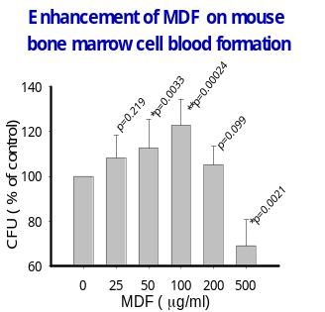

A second thought: should you report the coefficient of –0.00008? This can be interpreted as “for each increase in dose of one unit, increase in log tumor size is less by –0.00008”. I would argue that this coefficient might misleading because you only have a few doses and they are widely spaced. Also, dose-response is often non-linear: it generally takes a sigmoidal curve (see below). In short, you might too few data to be confident about a linear prediction. Finally, it is rare that you really want to estimate the effects of a treatment on a mouse: generally, laboratory studies are about testing hypotheses.

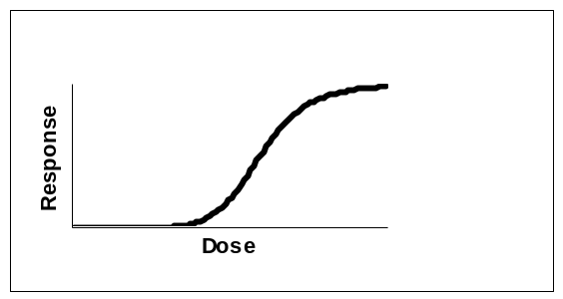

My model answer would be:

Mean increase in log tumor size per day by dose is given in the table. Higher doses were associated with lower growth rates (p=0.01 by linear regression).

Dose | Mean (SD)
0 | 0.069 (0.025)
4 | 0.046 (0.016)
40 | 0.039 (0.001)
400 | 0.022 (0.009)

05e.dta. These are data from a study of the use of complementary medicine (e.g. massage) by UK breast cancer patients. There are data for the women’s age, time since diagnosis, presence of distant metastases, use of complementary medicine before diagnosis, whether they received a qualification after high school, the age they left eduction, whether usual employment is a manual trade, socioeconomic status. What predicts use of complementary medicine by women with breast cancer?

This is a fairly simple analysis: the outcome is binary and as we want to make predictions we are going to want a logistic regression. It would be tempting just to throw all the variables into the analysis (“logistic CAM age t mets u q18 e m ses”). This would suggest that the strongest predictor is whether women used complementary medicine before diagnosis and that two other variables are predictive: women with a qualification after leaving high school are more likely to use complementary medicine, but use declines with age (older people are more conservative, or alternatively, wiser, depending on your point of view.)

However….

Should we just throw everything in the model? For example, only 6 patients have distant metastases. Secondly, many of the variables seem highly correlated. For example, age at which the patient left education and whether they received a qualification after the age of 18 are highly correlated as are socioeconomic status and whether the patient’s job is a manual trade. In clinical terms, you wouldn’t need to know the age that someone left education if you already knew whether they had a post-high school qualification. And as would be intuitive, regression does not deal well with correlated variables. To take an extreme example, take two variables “x” which is equal to height, and “y” which is equal to height plus 1 inch. These have a correlation of one. Regressing just variable x or y on shoe size you get:

shoe size = 0.6x - 30 or shoe size=0.6y - 31

What would you get for regressing x and y? Any of the following are possible:

shoe size = 0.3x +0.3y – 30.5
shoe size = 0.4x +0.2y – 30.5
shoe size = 0.1x +0.5y – 30.5

There is no way of telling these apart in terms of regression. Bottom line: care is needed with correlated variables both in a clinical / scientific sense (you don’t need both of two correlated variables in a model) and a statistical sense (regression results can be misleading).

So I would start with the full model and then remove the least predictive of socioeconomic status and manual trade, and the least predictive of qualification and age left education. You end up with “logistic CAM age t mets u q18 ses”. Now it appears that “q18” is predictive but not “ses”. So try removing one of these from the model in turn (“logistic CAM age t ses” or “logistic CAM age t u q18 ”). It turns out that both are predictive independently, but not together. When you think about this, it is because socioeconomic status is correlated with education. The most sensible thing to do is to leave “q18” in the model as a) it is slightly more predictive and b) it is easier to ask about; c) there are fewer missing data. As such, my “model answer” might be:

There were responses from 714 women, of whom 661 had data adequate for analysis. There were more missing data for socioeconomic status but this was not included in the final model. In a multivariable model, use of complementary medicine before diagnosis was the strongest predictor of complementary medicine use in women with breast cancer (odds ratio 7.3; 95% C.I. 4.4, 12.1; p<0.0005). Complementary medicine use was related to education. The odds of a woman with a qualification received after the age of 18 using complementary medicine were 1.9 (95% C.I. 1.3, 2.8; p=0.001) those of women without a qualification after high school. In a univariate model, higher socioeconomic status predicted use of complementary medicine, but this was dropped from the multivariable model due to collinearity with educational achievement. Older women were less likely to use complementary medicine (odds ratio 0.96 for a one year increase in age; 95% C.I. 0.94, 0.97; p<0.005). There was no statistically significant effect of time since diagnosis (odds ratio 1.01 per year; 95% C.I. 0.92, 1.12; p=0.8). This suggests that breast cancer patients who use complementary medicine are likely to start doing so shortly after diagnosis.

05f.dtaThese are the distance records for Frisbee for various ages in males. What is the relationship between age and how far a man can throw a Frisbee?

Well the obvious thing would be to “regress distance age” and you get a coefficient of 1.62, meaning that the furthest a man can throw a Frisbee increases by 1.62 meters further every year. But of course this is nonsense: you can’t throw further and further each year, athletic ability starts to decline with age. You can see this if you “twoway (scatter distance age)”. In other words, there is not a linear relationship between your age and the distance you can throw a Frisbee. There are two options. You can either do two linear regressions, one for age up to 30 and one for age >30. But this is a little sloppy: better, you could try including non-linear terms (see below). In either case, remember not to report p values or 95% confidence intervals: these are meaningless because there is only one record per distance.

For advanced students only:
Often the relationship between an x and a y does not follow a straight line. You may remember from high school that one way to get a curve is to have a quadratic equation including both x and x². So you have to great a new variable called age2 as g age2=age^2. Now “regress distance age age2”). This model (distance=11.60age – 0.149age² +8.13) fits extremely well (r2 of 0.86 v. 0.24 for the linear model). If you really remember your high school math, consider that for a regression equation “y=ax +bx² + c” you can work out the maximum y as –a/2b. We predict that the world record for distance will be held by a man who is –11.60/(2 * -0.149) = 38.9 years old.

05g.dta. You’ve seen this data set before. Patients with lung cancer are randomized to receive either chemotherapy regime a or b and assessed for tumor response. We know there is no difference between regimes (you can test this if you like). However, do the treatments work differently depending on age or sex?

The first thing to do here is to do the sub-group analysis, just to get a feel for the data. Try “sort sex” and then: “by sex: tab response chemo , col ch”. This shows that regime a is better for men (51% v. 39% response rate, p=0.036). For women there doesn’t seem to be a difference between groups. The next thing to check is whether sex in general makes a difference to response: “tab r sex, ch col” shows similar response rates (around 40 – 45%) for men and women.

Now we want to test for interaction between chemo regime and sex in a multivariable regression. First, we have to create the interaction term and then test it.

g i=0
replace i=1 if sex==0 & chemo==1
*the variable i is the interaction term, coded 1 for men on chemo regime a & 0 for everyone else
*now we are trying to predict response on the basis of sex, chemo regime and their interaction
logistic r chemo sex i

By the way, don’t try “logistic r i”, that is, include only the interaction term. This would involve a non-randomized comparison between men and women who received the same chemotherapy treatment.

You can repeat this for age by creating a new variable called “hiage”. First, get the median age (sum age, d). This is 42.5. Then:

g hiage=0
replace hiage=1 if age>42.5
sort hiage

Then do the subgroup analysis (“by hiage: tab r ch , col ch”). There do not appear to be any differences between groups. Now to do the interaction analysis, you can create an interaction term in one of two ways (g i2=chemo*age OR g i2=chemo* hiage). Whichever one you chose, interaction non-significant in a logistic regression with age and chemo (“logistic r chemo age i2”). Incidentally, you must put age in the model because, not surprisingly, it is statistically significant, with higher age being associated with a lower chance of response.

Incidentally, I have often emphasized the importance of including an estimate and a 95% confidence interval in any set of results rather than just saying "differences between groups were / were not significant". Interaction analyses are somewhat of an exception to this general rule. First, these tend to be secondary, exploratory analyses. Secondly, interaction is rather rare in medicine: treatments tend to work (or not work) regardless of a patients age, gender, race and so on. Thirdly, the coefficient for the interaction term can be quite difficult to interpret. So it is often appropriate just to say that you looked for an interaction and didn't find one. A model answer might be:

[describe main comparison between chemo regimens here. Describe age and sex here]. In a subgroup analysis, there appeared to a differential effect of the two regimens depending on sex. In men, response rates were higher for regimen B (51%) than regimen A (39%); response rates were more similar in women, though perhaps favoring regimen B (39% vs. 44%). Sex and sex by regimen interaction were entered into a logistic regression model of regimen and response, but the interaction term was non-signficant (p=0.14). There were no apparent differences in response depending on age: response rates were 54% v. 46% in patients aged below the median compared to 42% v. 36% in patients aged above the median. The interaction between regimen and age as a continuous variable was non-significant (p=0.6).

05h.dta. PSA is used to screen for prostate cancer. In this data set, the researchers are looking at various forms of PSA (e.g. “nicked” PSA). What variables should be used to try to predict prostate cancer? How accurate would this test be?

One approach to selecting which variables to include in a predictive model would be to do a regression. You could start with all the variables (i.e. “logistic cancer psa psan psai psant”). You might notice that psant is not a good predictor (p=0.3) and decide to take it out of the model. In a regression using the remaining three variables, psai is not statistically significant, and you might then want to remove that variable too. Both psa and psan are hightly predictive, so you could leave them in the model and use “lroc” to get the area-under-the-curve.

However, I would have my doubts about such an approach. What you are trying to do here is predict the presence of cancer as well as you can: the significance or otherwise of individual variables doesn’t really come into it. How I would lay about my analysis would be in terms of the area-under-the-curve of the model. So a model answer might be:

The cohort consisted of 353 patients. Values for PSA and PSA subtypes are shown in the table. Entering all four PSA variables into a logistic model to predict the presence of prostate cancer gave an area-under-the-curve (AUC) of 0.737. Nicked-to-total ratio was not a strong predictor and removing it from the model did not decrease AUC (0.738). Removing intact PSA from the model had a small but noticeable impact on AUC (0.729). We therefore recommend that further research use total, nicked and intact PSA to predict prostate cancer.

Table 1. Marker distributions

 | Median | Interquartile range
Total PSA (ng/mL) | 6.8 | 4.3, 10
Nicked PSA (ng/mL) | 0.47 | 0.28, 0.71
Intact PSA (ng/mL) | 0.48 | 0.38, 0.57
Nicked-to-total ratio | 0.069 | 0.046, 0.11

Table 2. Multivariable prediction model

N=353 | Odds ratio | 95% C.I. | P value
total PSA | 1.30 | 1.19, 1.42 | <0.0001
nicked PSA | 0.22 | 0.11, 0.48 | 0.0001
intact PSA | 0.41 | 0.15, 1.12 | 0.081

05i.dta
This is a randomized trial of behavioral therapy in cancer patients with depressed mood. Patients are randomized to no treatment (group 1), informal contact with a volunteer (group 2) or behavior therapy with a trained therapist (group 3). What would you conclude about the effectiveness of these treatments?

One approach to these data is to use a test called ANOVA. This addresses the question of whether there is some overall difference between the three groups, or, more specifically, tests the null hypothesis that the three groups are equivalent. But this isn’t a very interesting hypothesis. The other thing to do would be to conduct t tests on all possible pairs (i.e. no treatment vs. therapy; therapy vs. volunteer; volunteer vs. no treatment). But I am not sure that this is particularly interesting either.

What I would use is a regression analysis.

g treat=0
replace treat=1 if g>1
g therapy=0
replace therapy=1 if g==3
regress followup baseline treat therapy

What this does is to create two dummy variables “treat” and “therapy”. “treat” means that you had some kind of treatment, whether that was contact with the therapist of just with a volunteer. “therapy” means you say the trained therapist. So the groups are coded:

Group | treat | therapy
No treatment | 0 | 0
Volunteer | 1 | 0
Trained therapy | 1 | 1

Now when you regress the change score using the variables “treat” and “therapy” you get an estimate of the effect of just spending time with someone and the effect of seeing a trained professional. In my view, this fits in well with the original study design. A model answer might be:

Mood scores improved in the therapist (2.1 points, SD 0.88) and volunteer groups (1.0 points, SD 0.89) but not in the no treatment group (0.1 point worsening in score, SD 1.13). Interaction with a considerate individual appears to improve mood by 0.8 points (95% C.I. 0.5, 1.1; p<0.0005) with active behavior therapy further improving scores an additional 1.0 points (95% C.I. 0.7, 1.3; p<0.0005).

